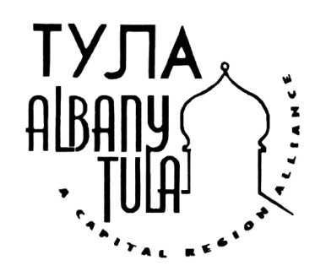

Kristina Krawchuk | KKMedia

518-426-5546 | kkimedia@gmail.com FOR IMMEDIATE RELEASE

THE SINGING ANCHORS TO PERFORM FOR ALBANY-TULA FUNDRAISER
(August 13) ALBANY. The Albany-Tula Alliance today announced that The Singing Anchors will at their September fundraiser on Sunday, September 18th at the Arts Center of the Capital Region. The fundraiser will begin at 6:00 pm with wine, food, and piano accompaniment by Findlay Cockrell, plus a chance for attendees to view the Alliance's retrospective exhibit, "Getting to Know You: 20 Years as a Sister City." The performance will begin at 7:00, and will be followed by desert and coffee.

The performers, local news anchors Benita Zahn, Jay Kerr, and Jessica Layton, put this show together for the Fort Salem Theater in 2010 and have since performed in several locations in Capital Region.

The Albany-Tula Alliance is grateful to our sponsors, who helped to make this performance possible. They include: mySmartSimulation, Stewarts, LinguaLinx, McNamee Lochner Titus & Williams, Northeast Health, CL King & Associations, Windsor Companies, Slingerland Foundation, CDPHP, Roger & Sherley Hannay, Steve Lobel, Multilogue Consulting, PilotGirl Productions, Price Chopper’s Golub Foundation, Madison Investment Advisors, Capital Care. AutoTask, and The Quinn Group. We are also grateful to the many private donors who contributed to this anniversary fund and to this performance. .
The Albany-Tula Alliance is a grassroots, not-for-profit volunteer organization composed of citizens of Albany and the surrounding Capital Region of New York State. Partnering with citizens of Tula, Russia, we have come together to provide mutual support and inspiration and to carry on a long-term program dedicated to the growth and well-being of both communities.

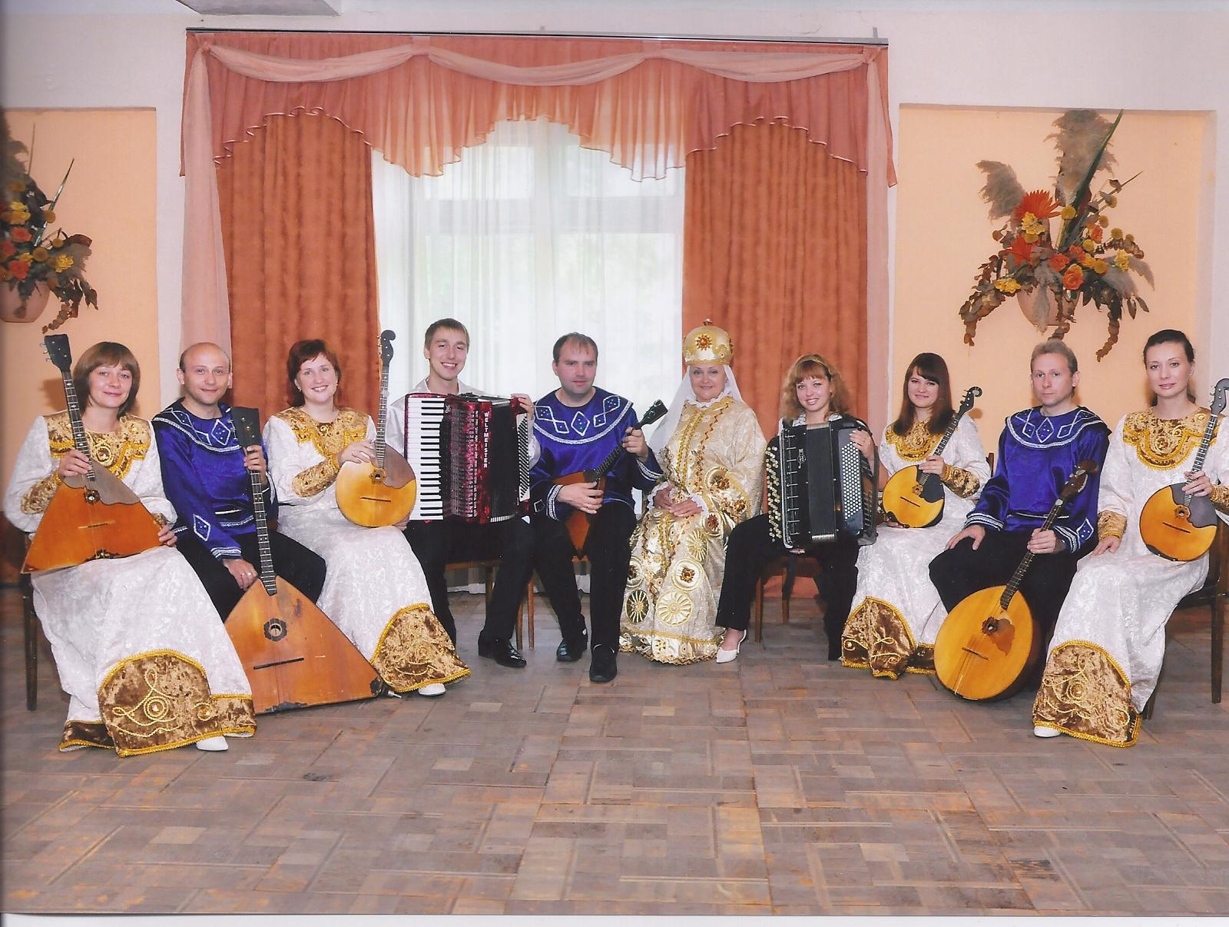

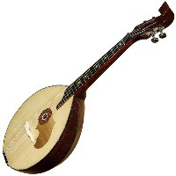
The Domra
Yasnaya Polyana Chamber Orchestra
Left to Right:
1) Zaikina Elena, balalaika alt
2) Rassatkin Yury, balalaika bass
3) Seregina Anna, domra alt
4) Vorobiev Sergey, accordion
5) Seregin Alexey, balalaika prima
6) Bogomolova Nina, soloist
7) Saratova Tatiana, button accordion
8) Yurieva Svetlana, domra minor
9) Rassatkin Vladislav, domra bass
10) Anesenkova Ekaterina, domra minor

